21BDS0340

Abhinav Dinesh Srivatsa

Course Code: BMAT101L

Course Number: VL2021220106765

Course Slot: L9, L10

# Digital Lab Assignment 4

## Problem 1

Draw the three-dimensional vector field for the vector F=icos(x^2)+jexp(y)+ksin(z^3) and visualize it.

### Code:

syms x y z

f = [x^2, exp(y), sin(z^3)];

P(x, y, z) = f(1); Q(x, y, z) = f(2); R(x, y, z) = f(3);

x = linspace(-4, 4, 11); y = x; z = x;

[X, Y, Z] = meshgrid(x, y, z);

U = P(X, Y, Z); V = Q(X, Y, Z); W = R(X, Y, Z);

subplot(2,1,1)

quiver3(X, Y, Z, U, V, W, 2);

title('3D Vector Space')

xlabel('x'); ylabel('y'); zlabel('z');

subplot(2,1,2)

% for better visualisation

quiver(X, Y, U, V, 2);

title('2D Projection of 3D Space')

xlabel('x'); ylabel('y'); zlabel('z');

### Output:

## Problem 2

Find the curl of the vector field F = cos(x+2y)I + sin(x-2y)j and visualize it with following features:

* Write Matlab code, Input & output.
* Use subplot for Figures\
  + 1­­­st window: curl using quiver3
  + 2nd window: quiver
  + 3rd window: curl using surf function
  + 4th window: combined of pcolor & quiver functions.

### Code:

syms x y z

f = [cos(x + 2*y), sin(x - 2*y), 0*x*y*z];

P(x, y, z) = f(1); Q(x, y, z) = f(2); R(x, y, z) = f(3);

crl = curl(f, [x, y, z]);

C1(x, y, z) = crl(1); C2(x, y, z) = crl(2); C3(x, y, z) = crl(3);

a = linspace(-1, 1, 21);

[X, Y, Z] = meshgrid(a, a, a);

CR1 = C1(X, Y, Z); CR2 = C2(X, Y, Z); CR3 = C3(X, Y, Z);

U = P(X, Y, Z); V = Q(X, Y, Z); W = R(X, Y, Z);

subplot(2,2,1)

quiver3(X, Y, Z, CR1, CR2, CR3, 2)

title('Curl with quiver3')

xlabel('x'); ylabel('y'); zlabel('z');

subplot(2,2,2)

quiver(X, Y, U, V, 2)

title('Vector Function with quiver')

xlabel('x'); ylabel('y');

subplot(2,2,3)

[X, Y] = meshgrid(a, a);

surf(X, Y, double(C3(X, Y, 0)))

title('Surf of Curl Function')

xlabel('x'); ylabel('y'); zlabel('z');

subplot(2,2,4)

pcolor(X, Y, C3(X, Y, 0))

shading interp

hold on

[X, Y, Z] = meshgrid(a, a, a);

quiver(X, Y, U, V, 2)

title('Vector Function with quiver and pcolor Curl')

xlabel('x'); ylabel('y'); zlabel('z');

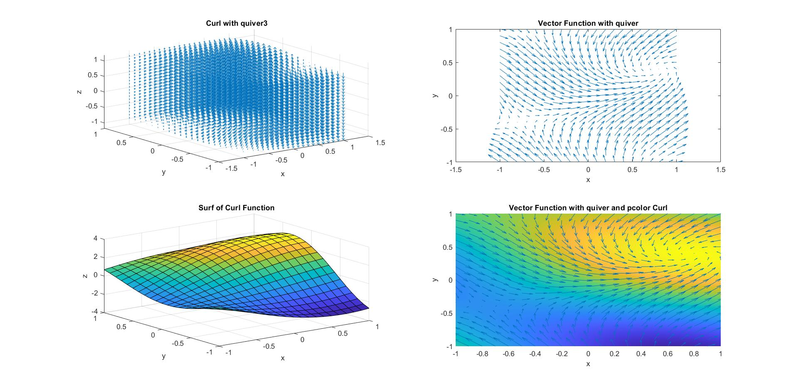Output: